AWS IOT CUSTOM (MQTT) AND DEVICE CONFIGURATION

GUIDE

**Contents**

1. General information 1

2. Create IoT Hub 3

2.1. Basics 4

3. Add device 6

4. Primary and secondary keys 10

5. Configuration 12

6. Certificate creation and upload 14

6.1. Converting certificate to .pem format 14

6.2. Upload certificate to device 19

7. Certificate key saving to device 20

7.1. Data sending 21

8. Checking received data in Azure IoT Explorer 23

8.1. Downloading Azure IoT Explorer 23

# General information

Firmware version: 03.28.06.Rev.280

Hardware revision: 288

Configurator: 1.7.45_B.3.28_R.11

Notes: This guide does not contain any information how to store received MQTT packets in the Azure.

# Create IoT Hub

Login to <https://portal.azure.com/>

Press  and select – **create new resource**

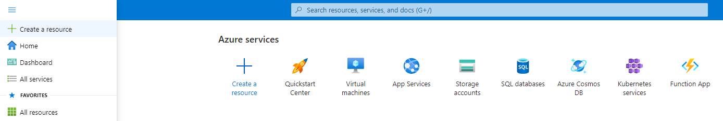

Figure 1 Create new resource

Select **Internet of things** in the Categories on the left

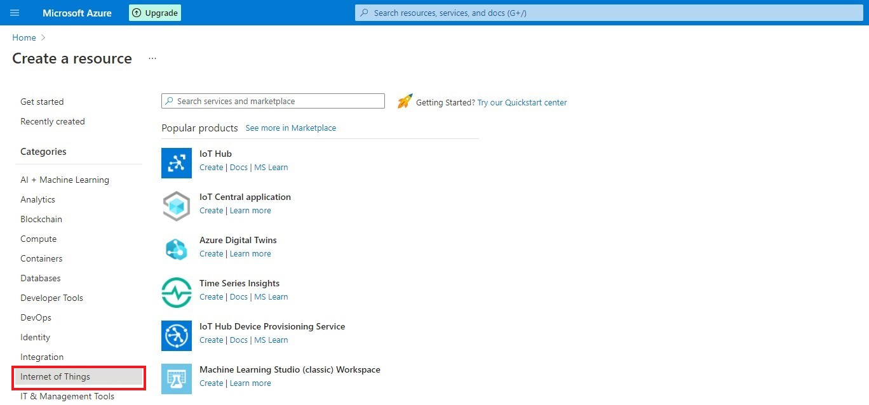

Figure 2 Selecting IoT

Press **Create** near the icon.

## Basics

In the **Basics** tab choose your **subscription**. Create a new **Resource group**. Enter **IoT hub name** (Can be any created name). Select **Region** that is closest to you.

Choose the wanted **Tier, Free** **tier** should be used for testing purpose, alternatively use **standard**. (You can find all the necessary information about tiers when you click **Comapare tiers** below option box).

Then choose your **Daily message limit** according to your needs (You can find all the necessary information about **Daily message limit** when you click **See all options** below option box).

Press: **Review + create**

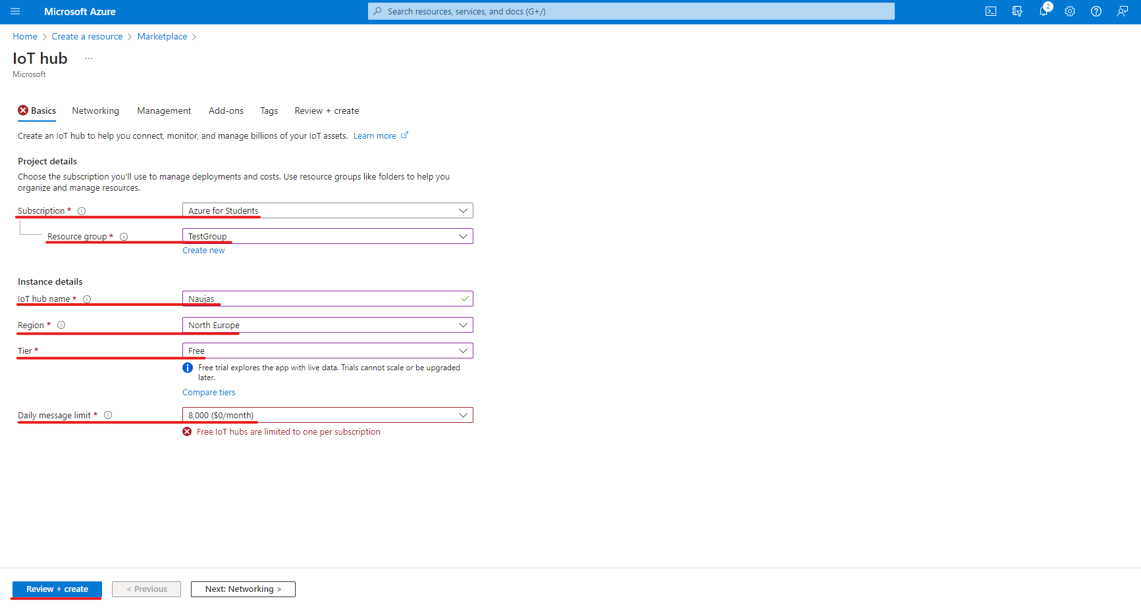

Figure 3 Basics parameters

Check if all the parameters are as you intended and click **Create.**

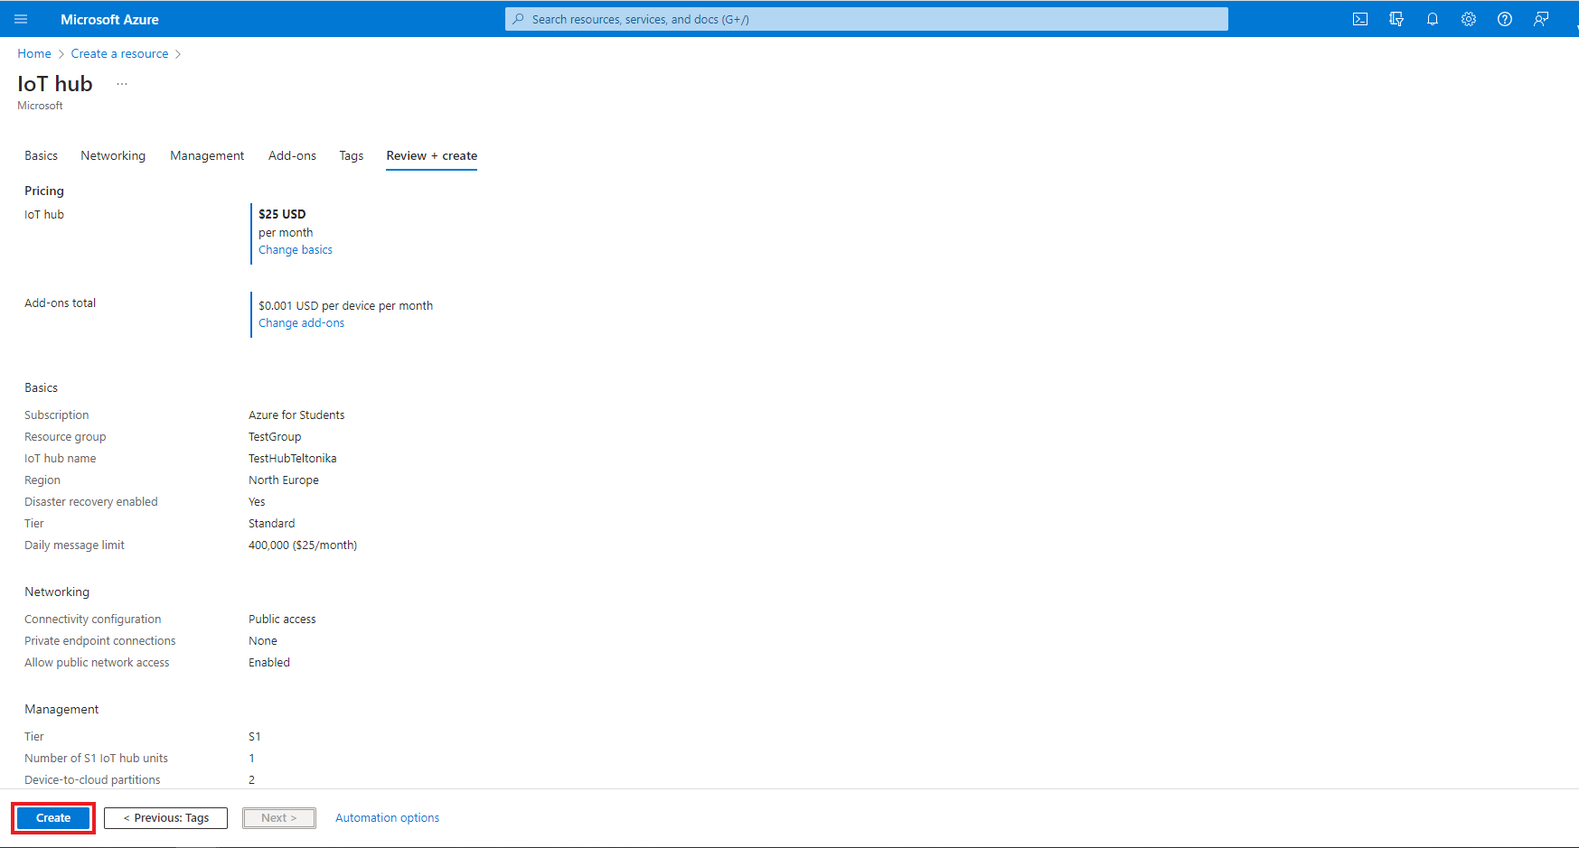

Figure 4 Creating IoT hub

# Add device

Press  , **Home** and click on your created IoT Hub.

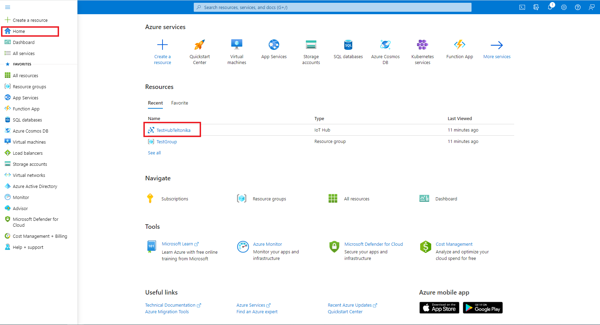

Figure 5 Selecting IoT Hub

Copy hostname and press **devices** In the left menu.

|  |  |
| --- | --- |
|  | **If you see a warning:** |
|  | * This resource uses a certificate on the Baltimore CyberTrust Root which will expire in 2025 and must be migrated to the DigiCert Global G2 root.   Go to: **Migrate to DigiCert Global G2** section at the bottom of this tutorial. |

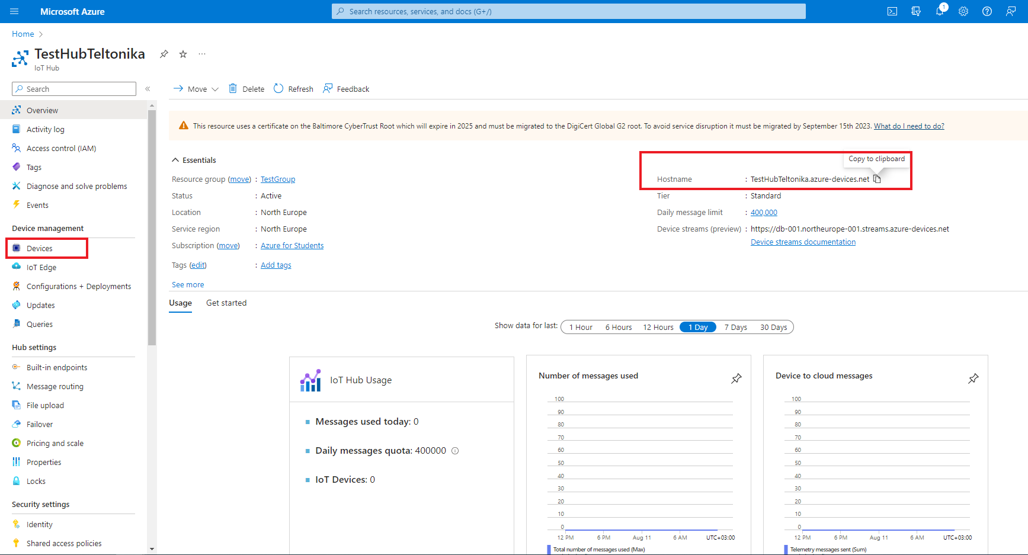

Figure 6 Domain and devices

Select **Add Device** in **Devices** tab.

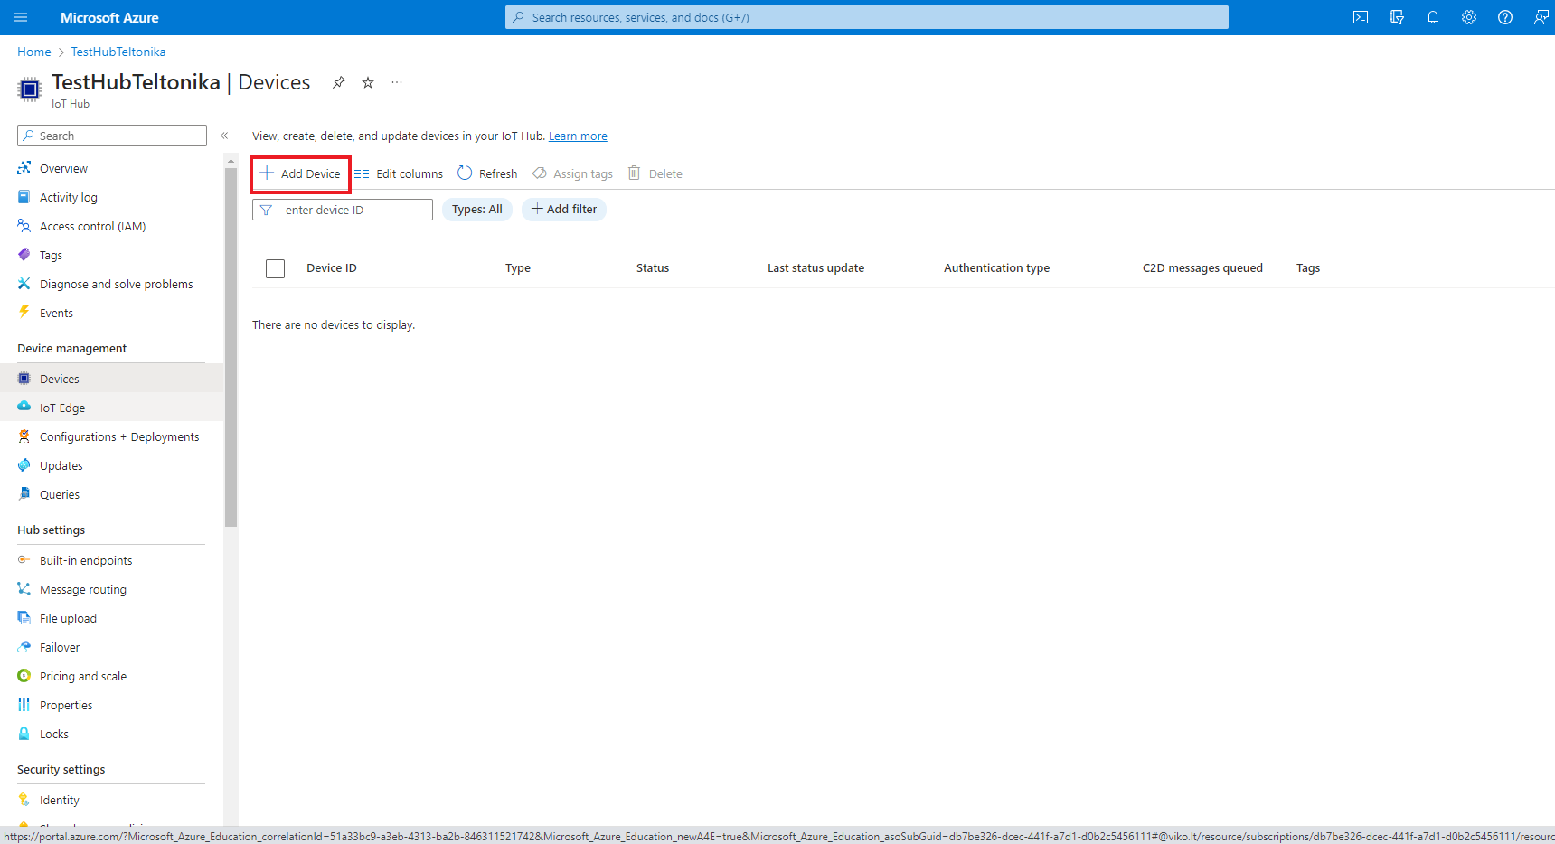

Figure 7 Add Device

Once you are inside **Create a device** tab:

Enter your device IMEI in the **device ID** field.

Other fields here should be left default

Authentication type: Symmetric key Connection this device to an Iot Hub: Enabled

Press **save**.

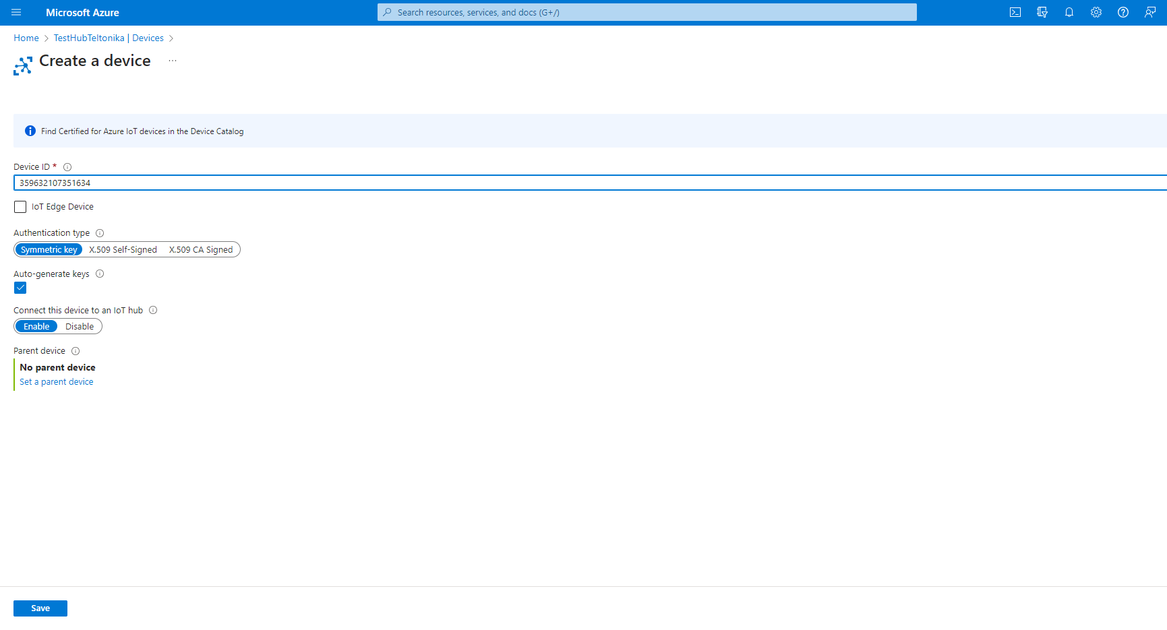

Figure 8 Creating a device

# Share access policies

To get your primary and secondary keys go to **Shared access policies,** change **Connect using shared access policies** to **Allow** and click on **iothubowner**.

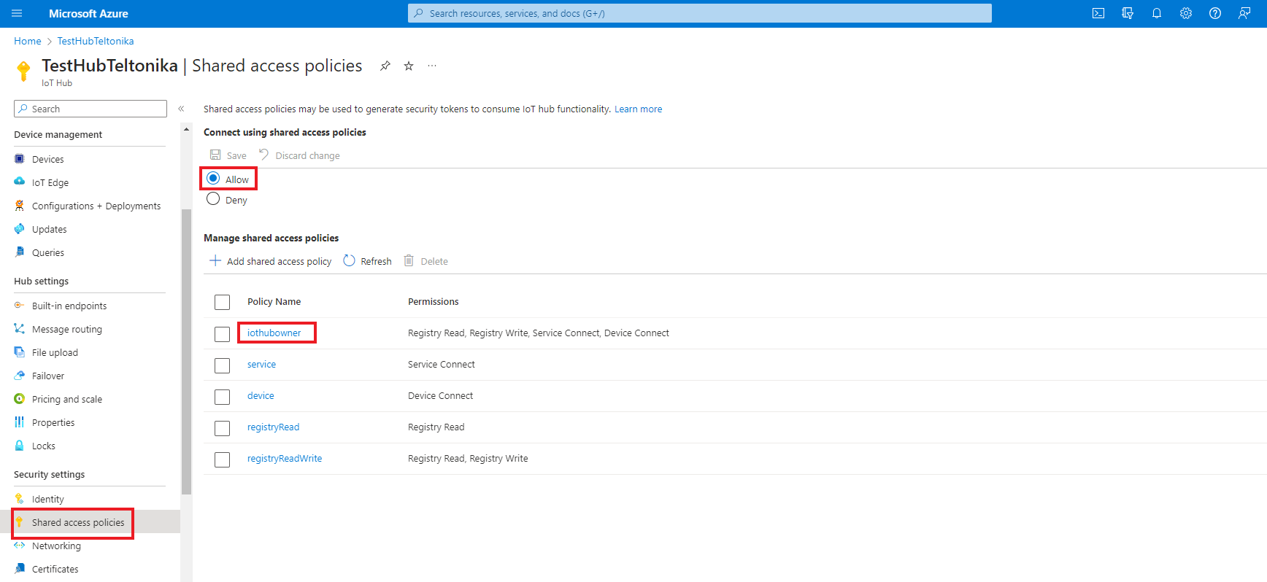

Figure 9 Shared access policies

An **iothubowner** tab will pop out on the right.

Copy:

1. Primary key
2. Secondary key
3. “iothubowner”

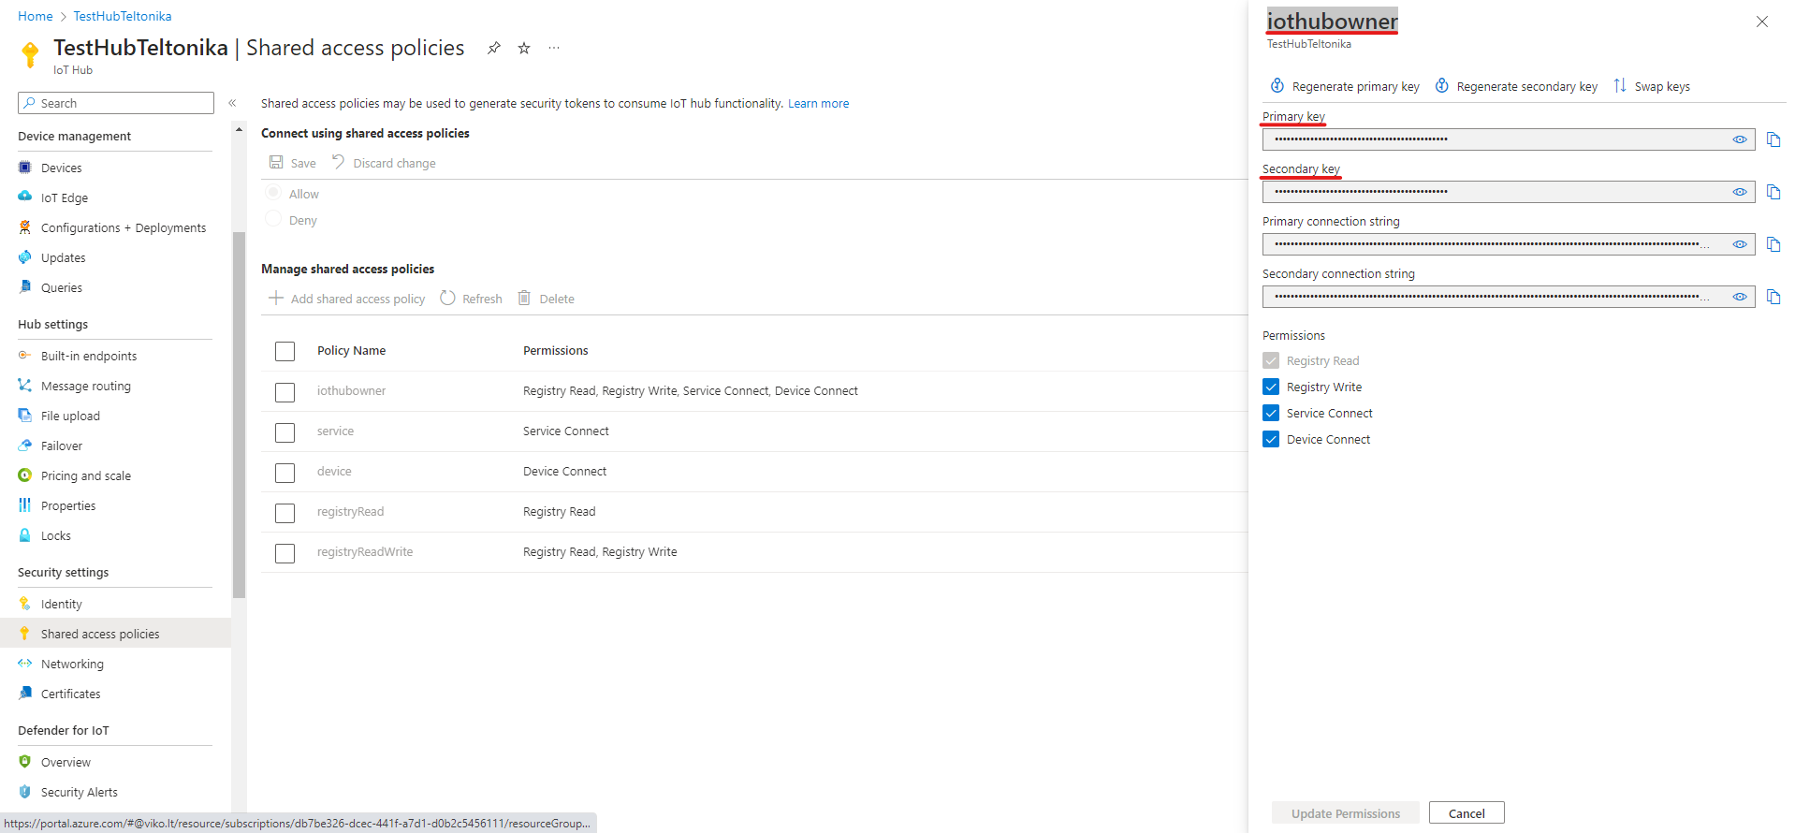

Figure 10 Saving keys

# Configuration

In the ***GPRS tab****,* under ***Server Settings***select:

1. Domain – **Hostname** (copy here the host name from your Iot Hub overview window in Azure)
2. Port: ***8883***
3. Protocol – ***MQTT***
4. TLS Encryption – ***TLS/DTLS***

In the ***GPRS tab****,* under ***MQTT Settings***select:

1. MQTT Client type – **Azure IoT**
2. Device ID: ***IMEI***
3. Primary SAS key – ***Primary key*** *from* ***‘iothubowner’*** *shared access policy*
4. Secondary SAS key – **Secondary *key*** *from* ***‘iothubowner’*** *shared access policy*
5. SAS Policy Name – ***iothubowner***

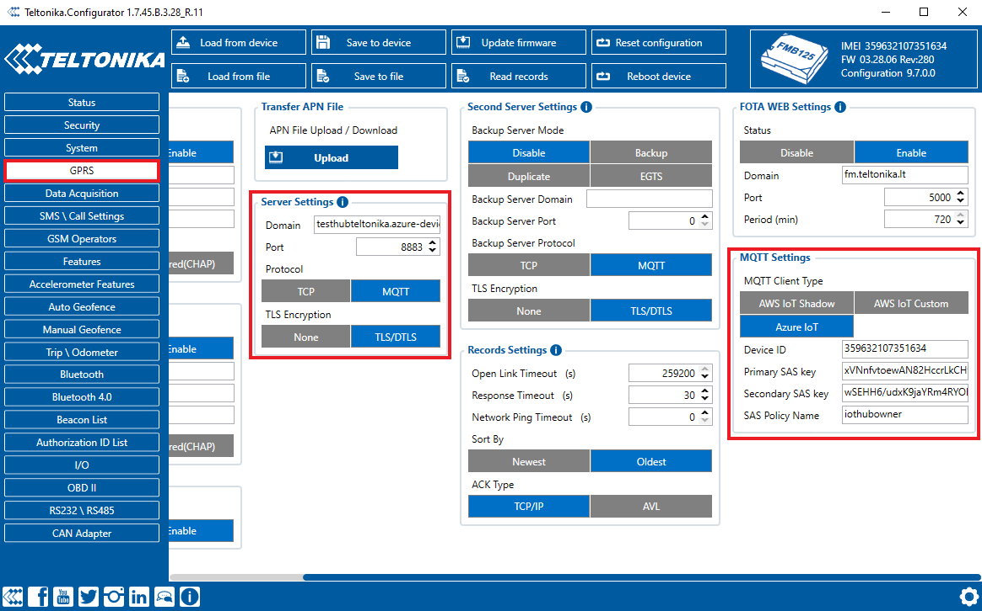

Figure 11 Device configuration

# Certificate creation and upload

## Converting certificate to .pem format

Download **DigiCert Global Root G2** and put it inside a new folder: [Download DER/CRT](https://cacerts.digicert.com/DigiCertGlobalRootG2.crt)

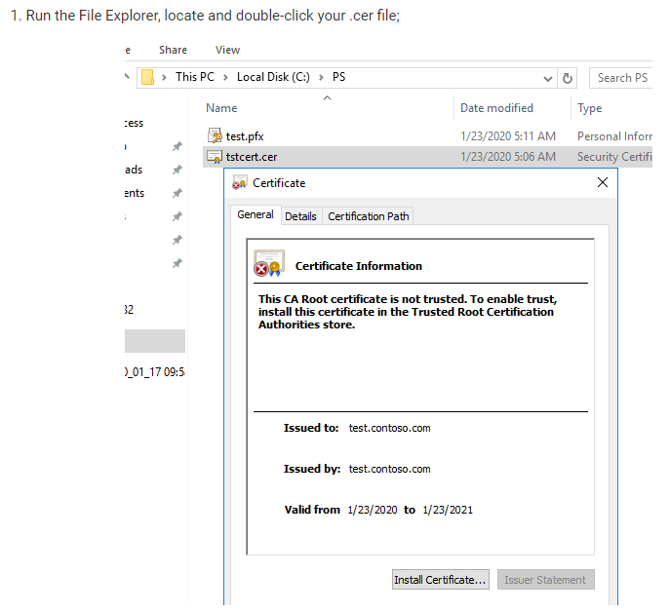

Figure 12 Certificate creation 1

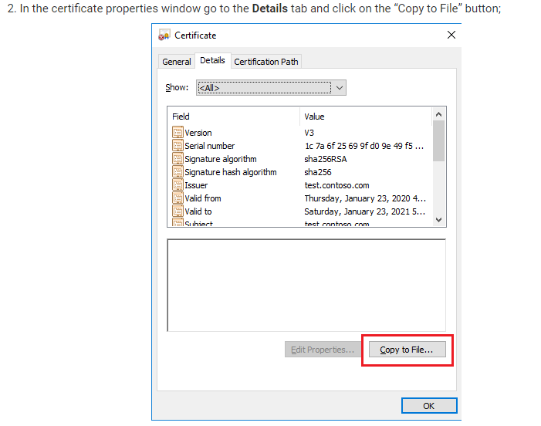

Figure 13 Certificate creation 2

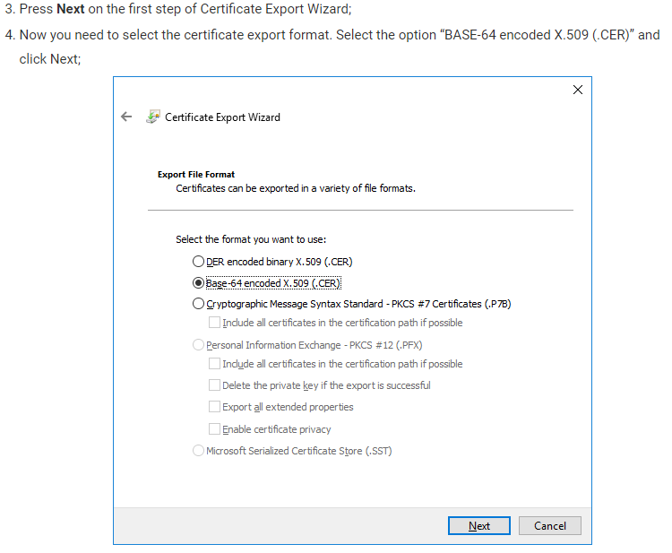

Figure 14 Certificate creation 3

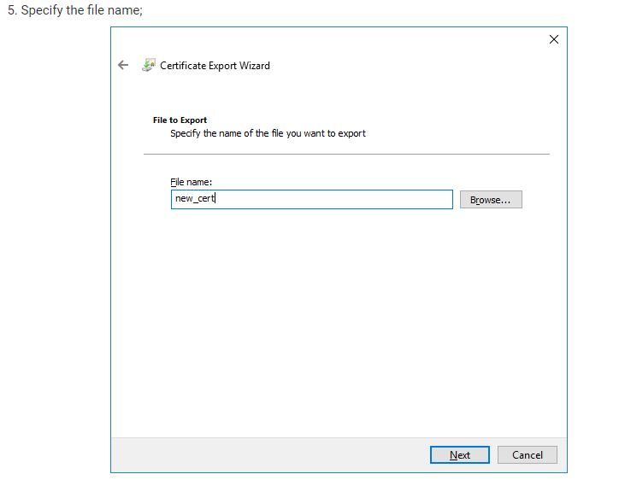

Figure 15 Certificate creation 4

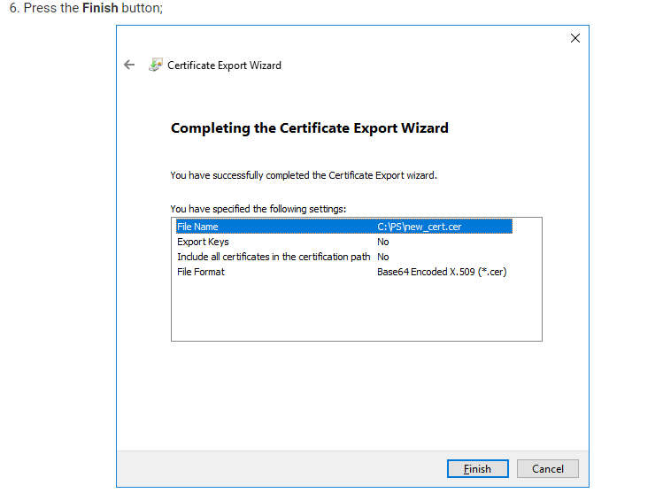

Figure 16 Certificate creation 5



Certificate.pem will be created.

Upload the file you have created to the device using configurator > Security > Certificate > upload

## Upload certificate to device

# Data sending

# Trigger a high priority event so that device would start to send data to the server.

In the device configurator screen check for the Status > GSM Info > Records Sent records count.

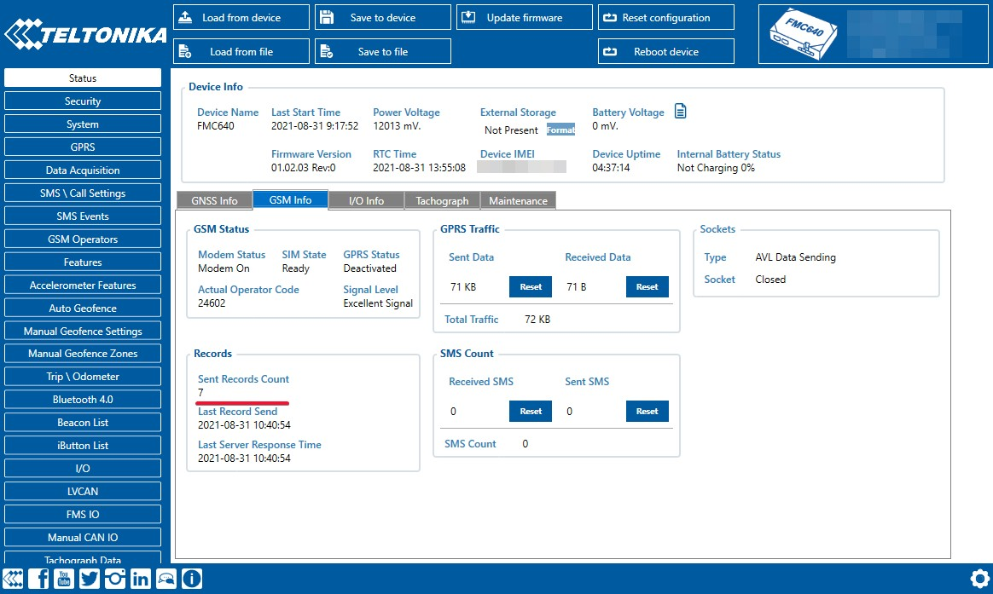

Figure 17 Sent records count

On the Azure service > IOT hub > Overview there is a Device to cloud chart that will show the records received. Be aware - this window has noticeable delay.

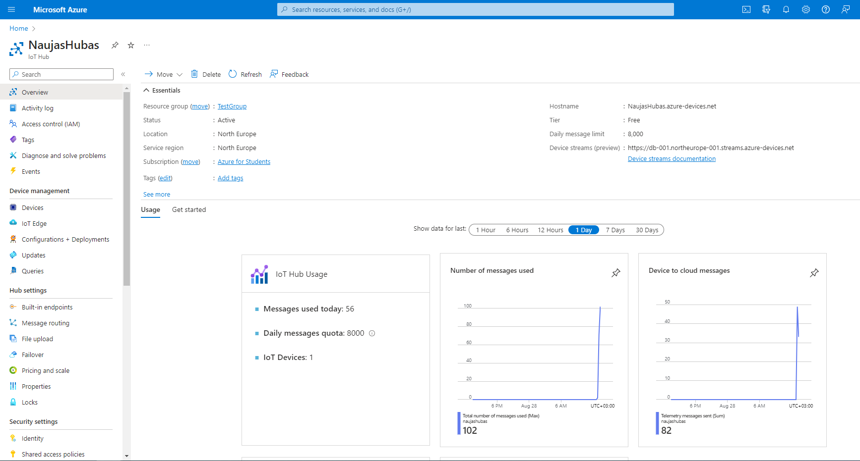

Figure 18 IoT hub overview

# Checking received data in Azure IoT Explorer

## Downloading Azure IoT Explorer

The data received from the device can be found in the **Azure IoT Explorer**

Go to: <https://github.com/Azure/azure-iot-explorer/releases>  
Find the latest version and download the file with .msi header:

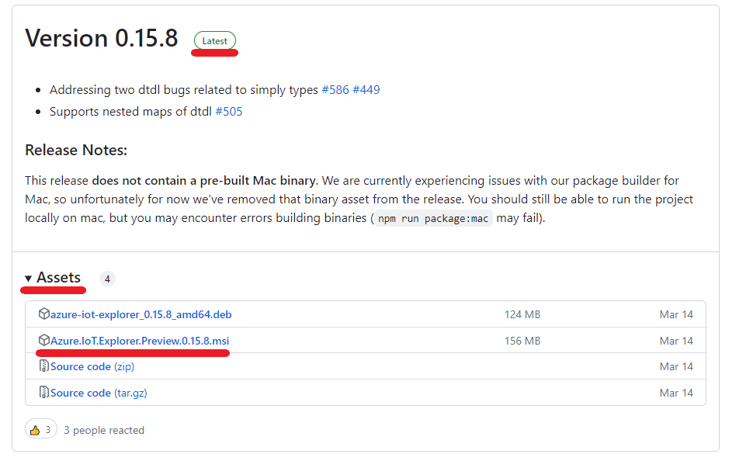

Figure 19 Azure IoT explorer 1

After opening Azure explorer click:

1. **IoThubs**
2. **Add connection**

In the pop-up bar enter **primary connection string** which you can get from **Shared access policies** which was explored in section 4.

Click **save** after completion.

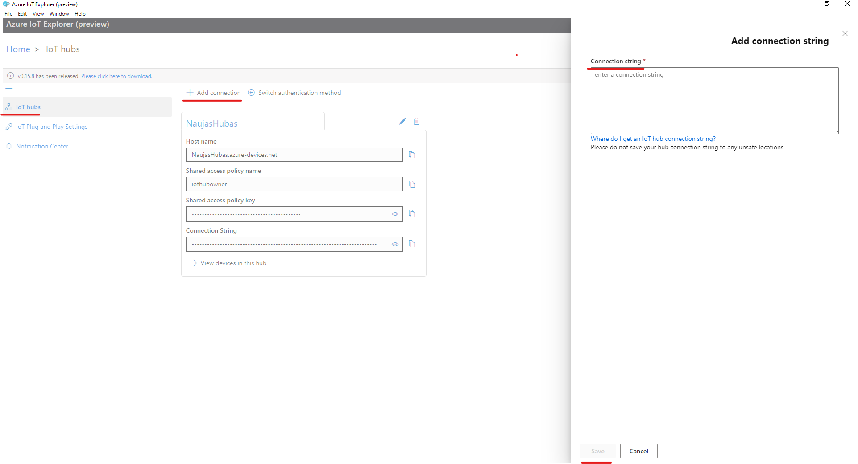

Figure 20 Azure IoT explorer 2

Click the Name of your hub which will be in blue color.

Select the device that you want to explore by **clicking** on it’s **IMEI.**

On the following window click **Telemetry** and the **Start.**

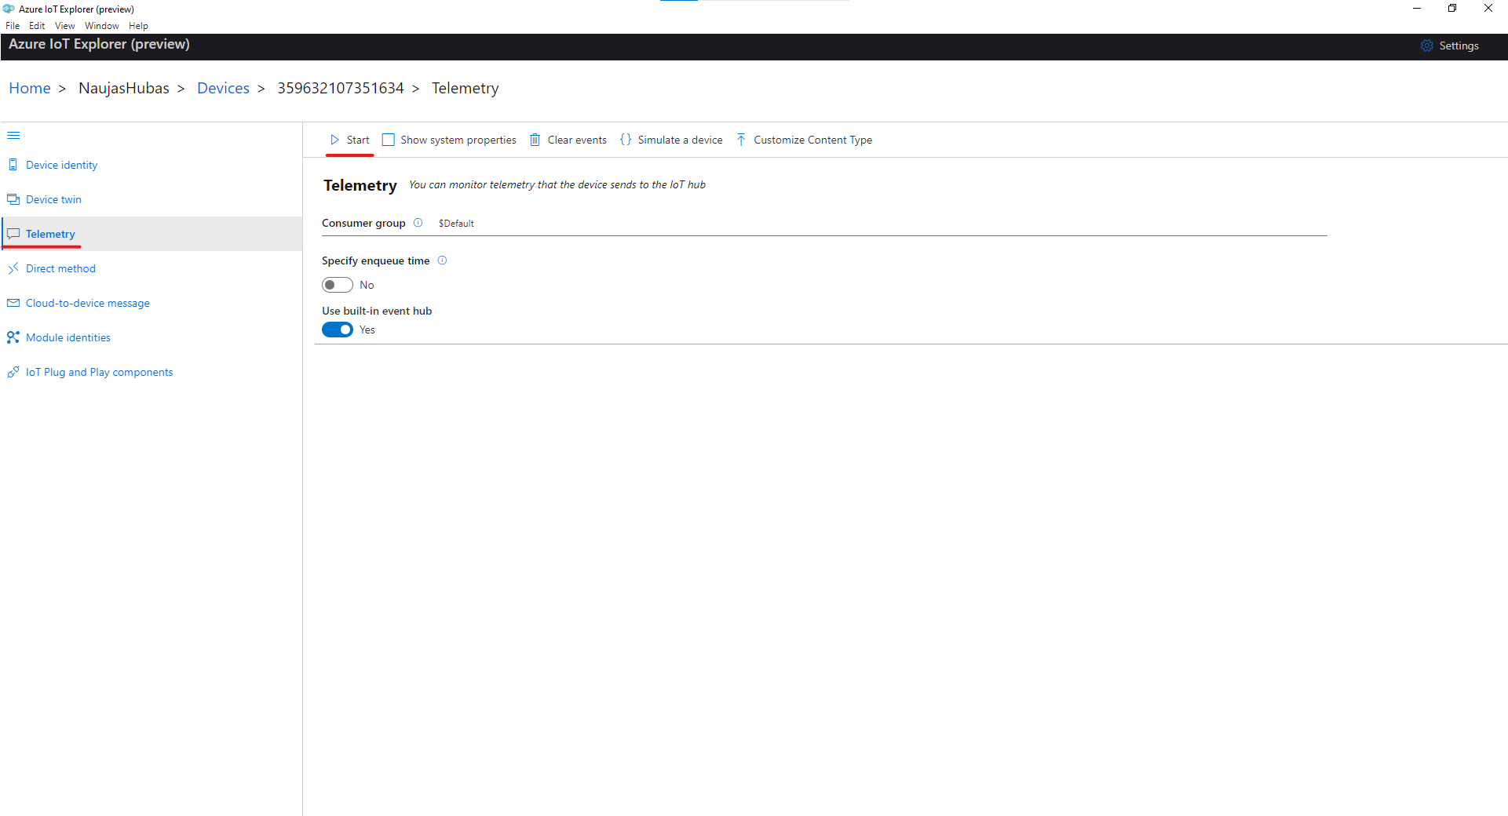

Figure 21 Azure IoT explorer 3

Example of data sent in JSON format:

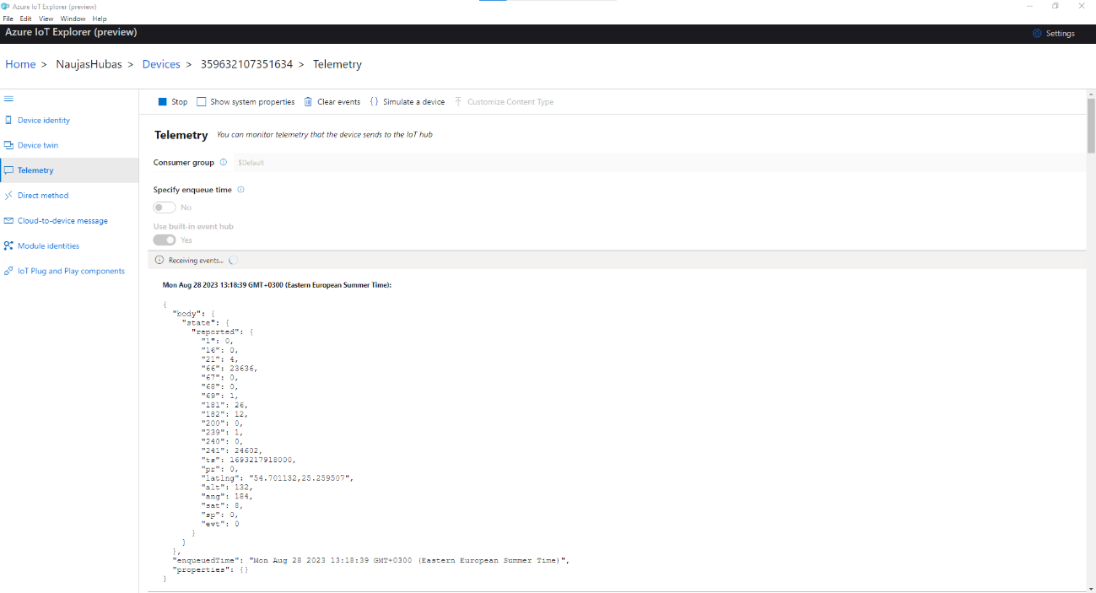

Figure 22 Records JSON

Example of data sent in Codec 8 format:

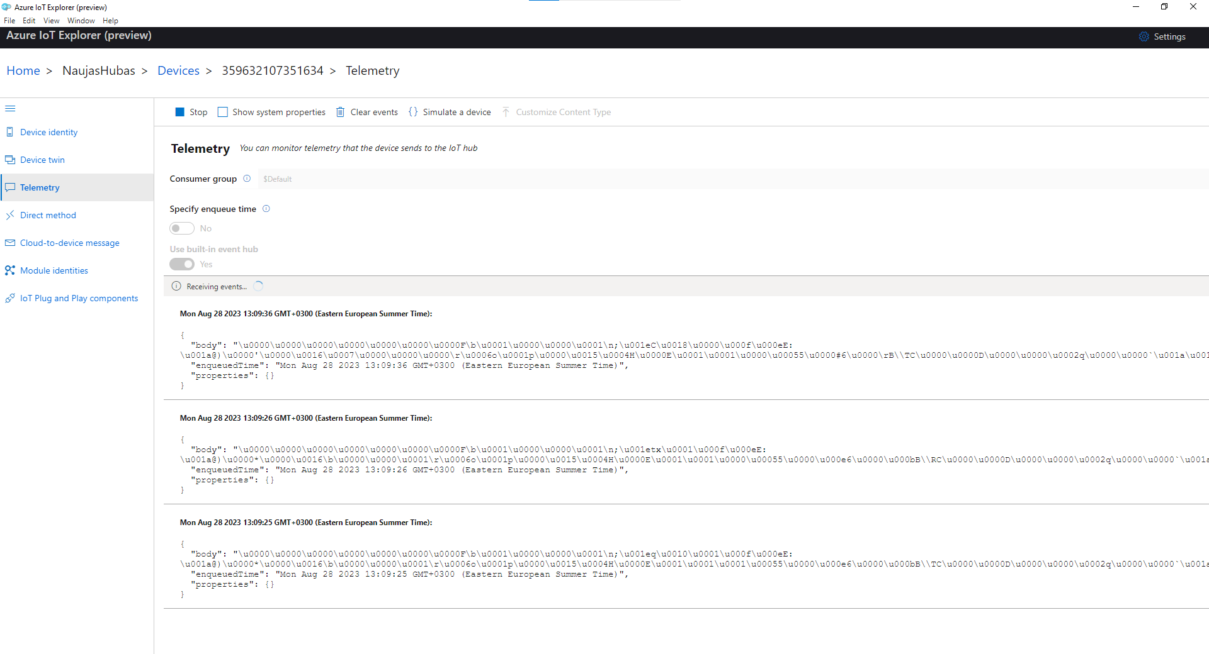

Figure 23 Records Codec 8

# Migrate to DigiCert Global G2 (If you saw a warning in overview)

# In overview window click on the red error message

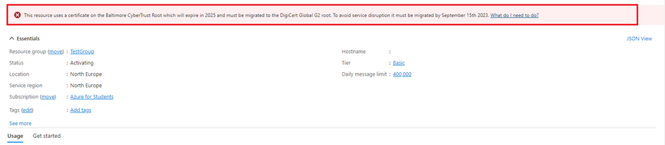

# In the following window click Migrate to DigiCert Global G2

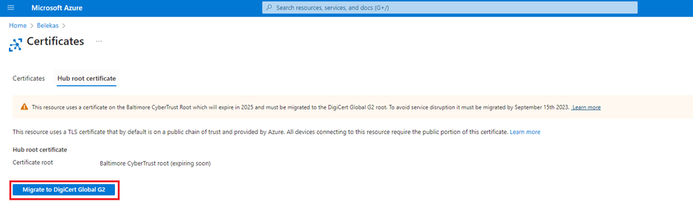

On the next window check all the boxes and click **Update**

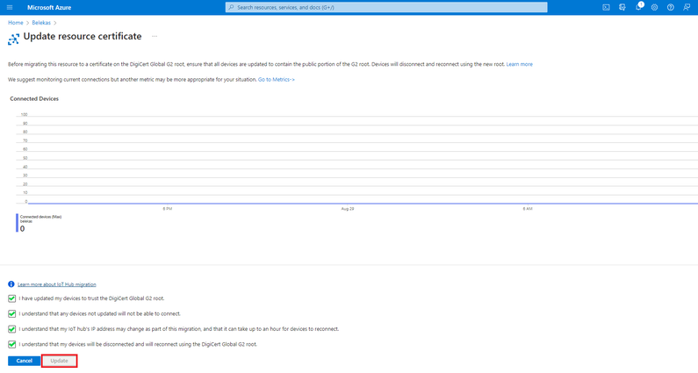

Migration may take up to a minute. You can now continue with the instructions from where you left off.